Assignment 1 Report

Mohamed Oun - 124897

# Problem 1:

### Given the Alphabet {𝑎, 𝑏, 𝑐} write a computer program in Java or C++ to construct a DFA which accepts: (𝑎|𝑏|𝑐) ∗ 𝑐. Set of strings of a’s, b’s and c’s ending with the string c.

## Problem description:

This machine needs to accept strings that begin with either a sequence of a’s or b’s or c’s or nothing (epsilon) and end with c. Examples: {c, ac, bc, cc, aac, bbc, ccc,…………..}.

## fLOW OF STATES:

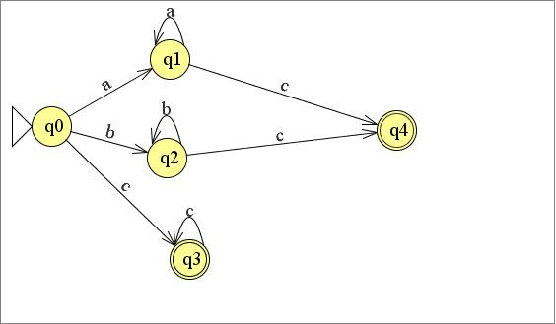

## language:

{a, b, c}

## States:

{q0, q1, q2, q3, q4}

## Initial STATE:

Q0.

## Final States:

{Q3,Q4}.

## Transition Table:

|  |  |  |  |
| --- | --- | --- | --- |
| State/Input | a | b | c |
| Q0 | Q1 | Q2 | Q3 |
| Q1 | Q1 | Null | Q4 |
| Q2 | Null | Q2 | Q4 |
| Q3 | Null | Null | Q3 |
| Q4 | Null | Null | Null |

## tESTS:

# Problem 2:

### Given the Alphabet {𝑎, 𝑏} write a computer program in **Java** or **C++** to construct a DFA for the following language: (𝑎 + 𝑏) ∗𝑎𝑏𝑏. Set of strings of a’s and b’s ending with the string abb, So L = {abb, aabb, babb, aaabb, ababb, ………….}

## Problem description:

This machine needs to accept strings that begin with a sequence of a’s or b’s or both or nothing (epsilon) and end with abb.

## fLOW OF STATES:

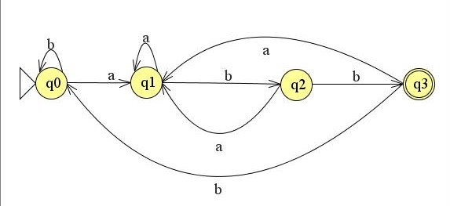

## language:

{a, b}

## States:

{q0, q1, q2, q3 }

## Initial STATE:

Q0.

## Final States:

{Q3}.

## Transition Table:

|  |  |  |
| --- | --- | --- |
| State/Input | a | b |
| Q0 | Q1 | Q0 |
| Q1 | Q1 | Q2 |
| Q2 | Q1 | Q3 |
| Q3 | Q1 | Q0 |